**Title**

**Contents**

**1.0 Executive Summary**

This report explores the processes, observations, key learnings and outcomes of conducting three lab tasks. This included exploring the Linux Iptables tools, and creating 4 different types of firewalls. The second lab task incorporated conducting NMAP scans using three flags of normal, UDP and XMAS scans. The final lab required the installation of the Snort Linux tool, to create rules that prevented the three NMAP scans as well as accessing a web domain and alerts fors an SSH Brute Force attack. The code snippets and outputs of these tasks were recorded and explained for each lab task.

**2.0 Introduction**

The SEED Ubuntu version 16.04 VM was already set up on the Virtual Box application and installed on a Windows 10 environment. Multiple Virtual Machines were created for all three lab tasks which included Iptables, NMAP and Snort rules.

*Virtual Box Environment* 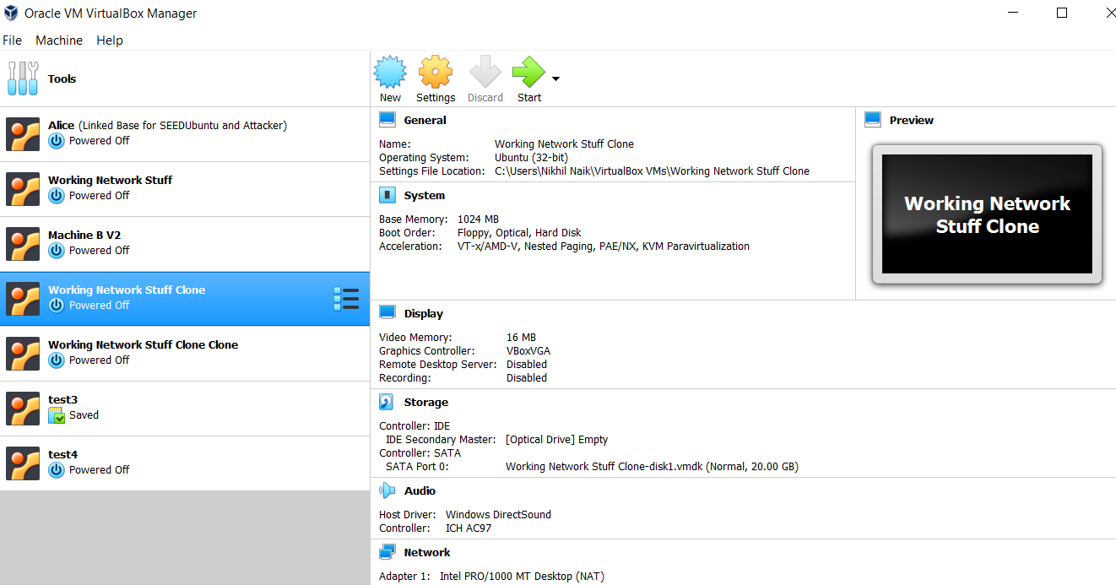

**3.0 Objectives**

**Iptables Lab:**

After completing this lab the main takeaways included the significance and flexibility of the Iptables custom rules. This should allow controlling the creation of Telnet connections between two machines. Secondly preventing a machine from accessing a specific website/domain. Finally, preventing a machine's response to ICMP packets received from an external device.

**NMAP Lab:**

On completion of the NMAP scans, the key takeaways incorporate information that can be deduced from each type of scan as well as the types of packets sent and received in that scan. The first scan of the normal scan should retrieve information about ports and their services that are open, through TCP packets. The second UDP scan should retrieve port information using both UDP and ICMP packets to determine this information. Finally, the XMAS scan should utilize the FIN, PSH and URG flags within the TCP segment to determine the port information of the target machine.

**Snort Lab:**

From the final lab task, the central learning should be the use of Snort to control and alert a machine about a potential network intrusion risk. This first 3 tasks involved creating alert rules within the Snort local rules file to alert on the three types of normal, UDP and XMAS nmap scans. The fourth task should alert when a specific web domain is attempted to be accessed using the local machine. Since the arrival data is encrypted, the TCP segments payload of the outgoing TCP segment should be analysed. The final task will incorporate alerting the local machine when an external machine fails to login to the SSH server 5 times in 120 seconds.

**4.0 Timeline**

Date completed for each of the SEED lab tasks are illustrated below:

1. **Iptables Host-Based Firewall Lab:**

* Task 1: 08/10/2020
* Task 2: 07/10/2020
* Task 3: 09/10/2020
* Task 4: 08/10/2020

1. **NMAP Lab:**

* Task 1: 09/10/2020
* Task 2: 09/10/2020
* Task 3: 09/10/2020

1. **Snort Lab:**

* Task 1: 14/10/2020
* Task 2: 14/10/2020
* Task 3: 13/10/2020
* Task 4: 15/10/2020
* Task 5: 17/10/2020

**5.1 Iptables**

**Task 1 Prevent Machine A from doing Telnet to Machine B**

This first task incorporated making use of the Linux based tool ‘Iptables’, which is a Host-Based firewall. The required task involved preventing Machine A from establishing a Telnet connection to Machine B. The first step in this task involved setting up two different virtual machines as Machine A (10.0.2.15) and Machine B (10.0.2.7). Once these virtual machines were configured, the Iptables tool could be utilised in Machine A (Figure 1 & 2).

*Figure 1: Machine A ifconfig*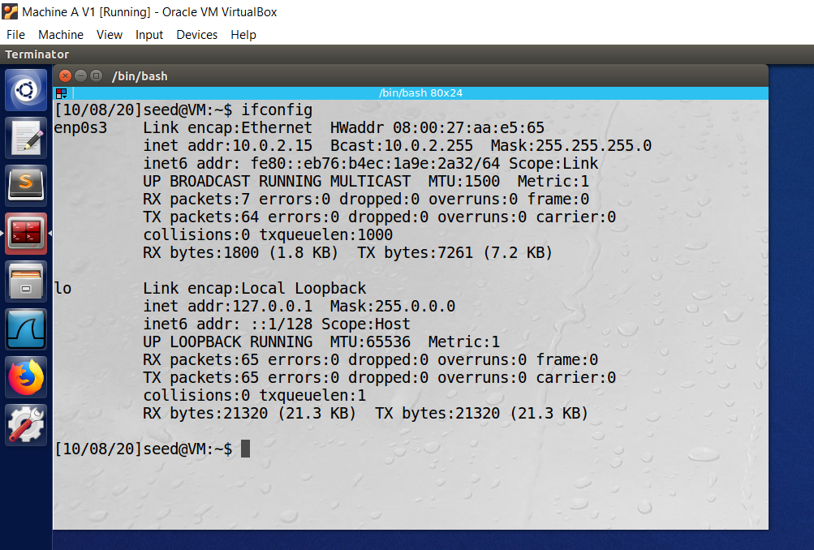

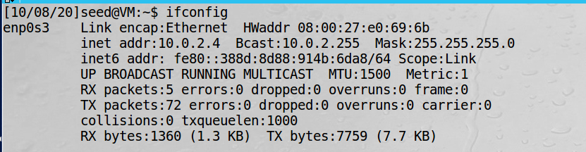

*Figure 2: Machine B ifconfig*

After setting up the two Machines it was deduced that some commands and manipulation of outgoing and incoming connections required root access. Hence the Ubuntu root access mode was entered in order to manipulate the Iptables host based firewall (Figure 3).

*Figure 3: Root mode access*

After entering root mode the Iptables manual was referenced for a list of usable commands in blocking and outgoing Telnet connection to a specific IP address. From the command list it was noted that a few flags and conditions would be useful when creating an iptable administrator rule. The first was the ‘-A’ which was observed to allow this created iptable rule to be added to the end of the current chain rule specification for Machine A. The next flag was the ‘OUTPUT’ function which allows exemption control from Machine A generating packets in order to create a connection to Machine B. After this was the ‘-p’, which was the protocol used to specify that the connection to control would be TCP. This is due to the notion that a Telnet connection uses the TCP protocol to establish a connection between two entities [1]. The next flag was the ‘-s’, this allowed specification of some network address which would be in the iptable rule. Since the task was to prevent Machine A from doing Telnet to Machine B, the IP address for Machine B was specified for this field as 10.0.2.4, such that this was the IP address to prevent an outgoing connection to be established. The next condition to be specified was ‘--dport’ which would allow the firewall to block all requests going to the Telnet service, to the specified network IP address. The final parameter was ‘-j’, which allowed control over outcome if all the Iptables rules conditions were met. Hence, since the task was to prevent Machine A from creating a Telnet connection to Machine B, the REJECT function was used to display the message that the destination of Machine B is unreachable. This Iptable rule was created and executed in the shell of Machine A (Figure 4).



*Figure 4: Shell Iptable rule*

After creating this Iptable rule it was important to understand whether the IP address given from Machine B would be blocked by Machine A when trying to establish a Telnet connection. The result of this is evident below (Figure 5).

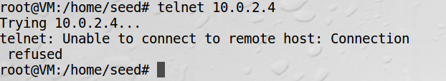

*Figure 5: Attempted Telnet request*

As observed when attempting to establish a Telnet connection to Machine B, the created Iptable rule blocked this network connection from occurring. This aligned was the prediction, as the REJECT clause was displayed, hence meaning the previous conditions to block the connection attempt were also met. Thus, the task of preventing Machine A from doing Telnet to Machine B was achieved successfully. However, it was also important to understand whether there were any external factors in blocking this connection. To validate that no other factors played a role in this firewall, all the Iptable rules in Machine A were dropped, and a telnet connection attempted to be created (Figure 6, 7 & 8).

*Figure 6: Iptable existing rules*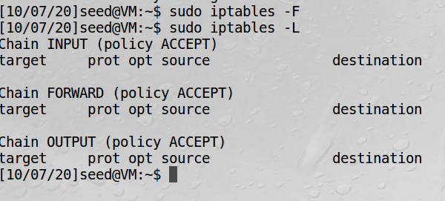

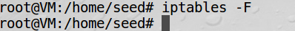

*Figure 7: Dropping Iptable rules*

*Figure 8: Telnet Access request*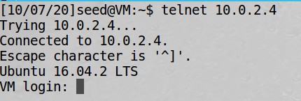

As observed above as expected when the Iptables firewall protection rule was dropped from Machine A, a telnet connection was able to be established to Machine B. This mitigates any external factors, hence validating the effectiveness of the Iptable rule created to prevent Machine A from creating a Telnet to Machine B.

**Task 2 Prevent Machine A from being Telnet by Machine B**

This second task required again making use of the Iptables customized firewall protection, to this time prevent other Machines from creating a Telnet to Machine A. To do so the same virtual Machines were again used as Machine A (10.0.2.15) and Machine B (10.0.2.7). The IP address of Machine B was changed to 10.0.2.7 using ‘ifconfig’ to mitigate any linkages from the previous task (Figure 9 & 10).

*Figure Machine 9: Network information*

*Figure Machine 10: Network Information*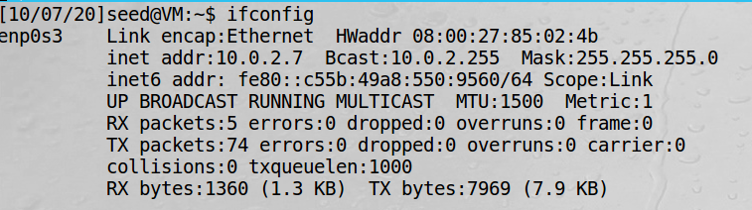

This task required an Iptable rule to be created to prevent a specific Machine from establishing a Telnet connection with Machine A. To do so the Iptables manual was retrieved and various functions and flags relevant to preventing a specific IP address establishing a Telnet connection were understood. The first condition for the Ipable rule was again the ‘-A’ flag, which allowed the rule to be appended to the chain rule specification for Machine A’s firewall. The next condition specified was ‘INPUT’, since this specified the case when packets were coming from an external connection. Since Machine B would be sending packets to Machine A to establish a connection, this flag was used to specify this condition. Again similar to the previous condition the ‘-p’ and ‘-s’ flags were used to specify that the type of connection would be TCP and the IP address of the Machine attempting to connect would be 10.0.2.7. The ‘--dport’ flag was also used to again specify that the requests going to the Telnet service should be blocked. The final condition was this time used as DROP, which would block the incoming Telnet request packets from Machine B. This Iptable rule was added to Machine A’s iptable rules in the shell (Figure 11).

*Figure 11: Iptable rule within shell*

Once this command was executed it was observed that the rule was added to the list of Iptable firewall protection rules for Machine A. To understand whether this was successful, a Telnet connection from Machine B to Machine was attempted to be created in the shell (Figure 12). 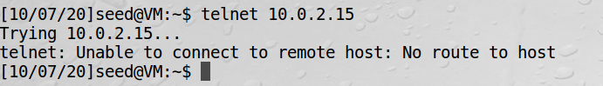

*Figure 12: Attempted Telnet connection*

Using Machine A’s IP address to create a connection, this connection was rejected by the host Machine A. This was expected as the conditions set using Machine A’s Iptables prevented Machine B from creating a Telnet connection and sending packets to Machine A. The key takeaway was the significance of Iptable conditioning, in preventing external devices from creating a connection to Machine A.

**Task 3 Prevent Machine A accessing an External Website**

The premise of this task again incorporated making use of the Host-Based Firewall of Iptables in Machine, this time to block accessing a specific website. The majority of websites or web-servers have an IP address, or IP address range, which can be retrieved by using the ‘Ping’ based Linux command [2]. For this task, the selected external website was the video streaming platform of ‘www.twitch.tv’. The purpose of this task was to not only prevent Machine A (10.0.2.15) from being able to ping the external website, however also prevent all access to that external website (Figure 13) .

*Figure 13: Target external website* 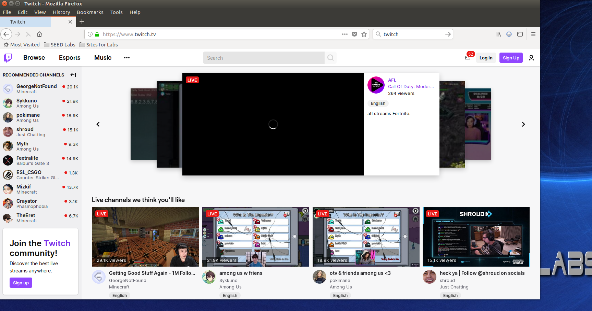

The first step was to verify that Machine A could be able to access the external sites IP address. This was done using the ping command, and the incoming and outcoming packets observed (Figure 14).

*Figure 14: External website ping shell output*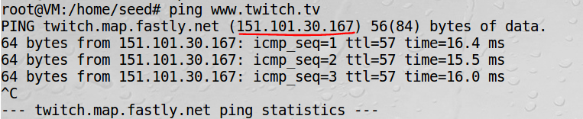

After establishing a connection both ways from Machine A to the external websites web server, the next step was to create the Iptable firewall condition. Again as previously this involved specifying conditions when met, to prevent a certain outcome from occurring. This was done firstly using the ‘-A’ specifier which would append the rule to the chain rule specification for Machine A’s firewall. The OUTPUT condition was used as well, since Machine A to generate request packets to the external websites server should be prevented in order to block that connection existing. The ‘-d’ flag was used as the destination for the request packets from Machine A to the twitch web servers. This was an important condition was the task required preventing Machine A from sending requests to the site to establish a connection. The IP address for the twitch webserver was used as the destination address of 151.101.30.167. The final flag was the ‘-j’, which allowed control over outcome if all the Iptables rules conditions were met. Hence, since the task was to prevent Machine A from sending request packets to the external website. Finally the REJECT function was used to display the message that the destination of the external website is unreachable. This Iptable rule was created and executed in the shell on Machine A, the external website was then attempted to be pinged (Figure 15).

*Figure 15: Iptable rule and ping request*

*Figure 16: Ping request in shell*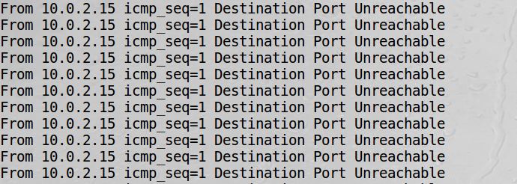

As observed above (Figure 16), the ping request on the external website returns the expected REJECT condition, of the destination being unreachable. This output confirms that the initial conditions were met of Machine A wanting to send request packets to the external website. Hence, the initial success of the Iptable firewall in preventing Machine A from sending requests to the destination. However to verify that the protection measure was successful the external website web page was refreshed and the outcome observed (Figure 17).

*Figure 17: External website in Firefox* 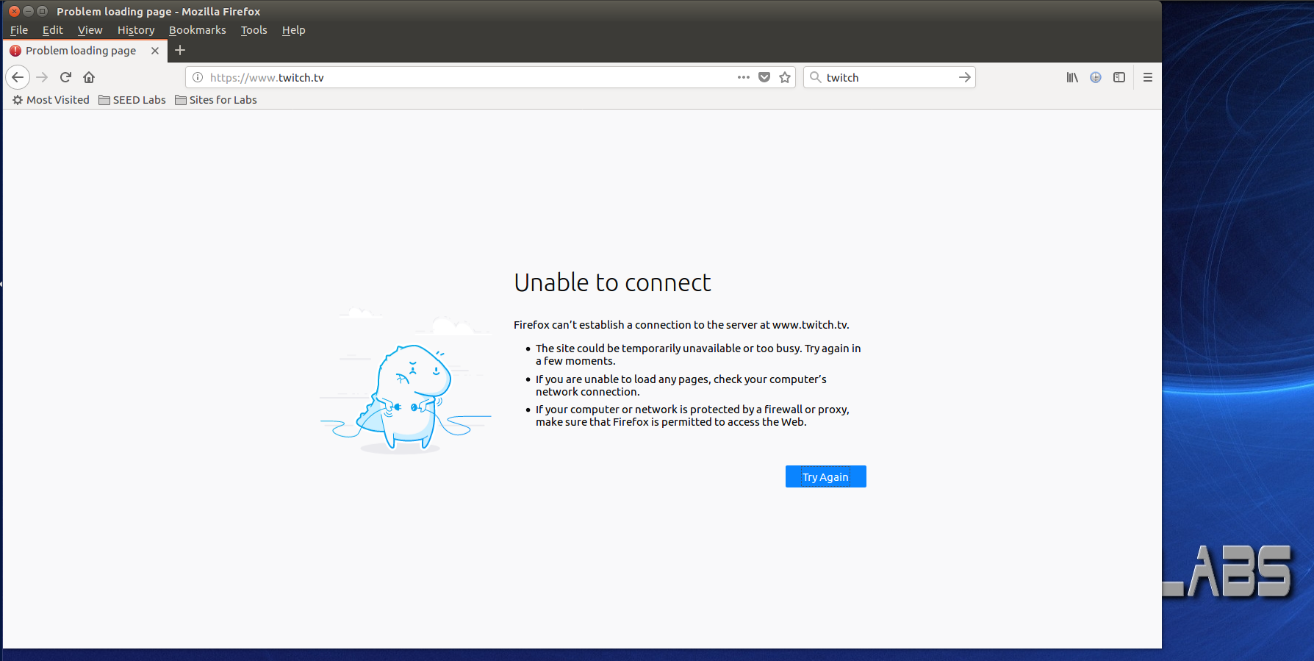

As observed the www.twitch.tv external website didn’t only block the ping request, but also blocked all access to the website. This verified the complete success of the Iptable rule created on Machine A, in preventing Machine A from accessing the external website. An interesting observation was whether the connection to the external website could be established. This was done by dropping all the Iptable rules (Figure 18).

*Figure 18: Dropping Iptables request*

The result of pinging the same webserver and refreshing the external websites page from Machine A is illuminated in (Figure 19).

*Figure 19: External website after dropping rule*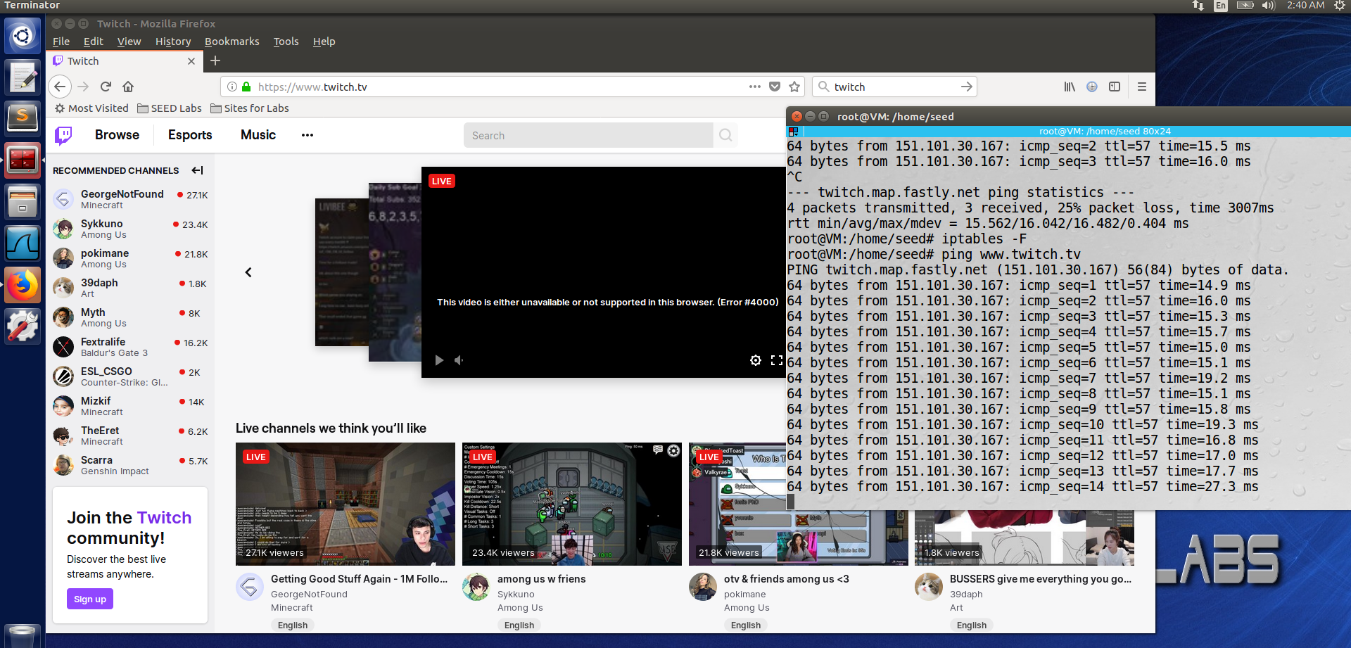

As expected it was observed that the ping requests and website reload were successful in attaining access to the www.twitch.tv web servers. Thus, the key learning from this task was the usefulness of Iptables in creating a conditional rule that prevents a Machine from accessing any external website or web server.

**Task 4 Prevent Machine A response to ICMP (Ping) Request**

The final Iptables task which again made use of the Host-Based Firewall, incorporated creating a rule to prevent Machine A (10.0.2.4). It was known that to ping Machine A, Machine B (10.0.2.7) was used to attempt to send a ping request to Machine A. The first step involved testing the connection between Machine A and Machine B could be created without any errors. This was done from Machine B using the ping command (Figure 20).

*Figure 20: Initial ping request to Machine A*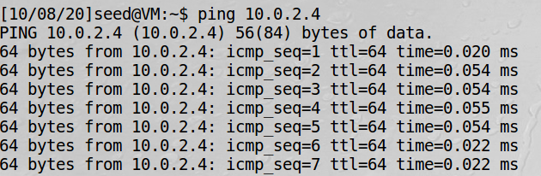

It can be observed that the ping request from Machine B is sending packets, which is then reciprocated by Machine A. This firstly demonstrated that Machine A is responding to ICMP requests. The next step was to again make use of the Iptables rules to develop a custom firewall to prevent Machine A from responding to ping requests. To understand what flags and conditions were required, the Iptables manual was used to reference which conditions would be required to add the rule to the filter table. The first flag was the ‘-A’, which is a specifier that would append the rule to the chain rule specification for Machine A’s firewall. The next flag was INPUT, which specified control for when packets were coming from an external connection, this was important as the ping requests from Machine B which is external. The ‘-p’ condition was the protocol of the rule or packet to check. This included the specifier protocol ‘icmp’, which is an echo request/reply also known as the ping request [3]. Since the task was focused on preventing these requests, it was only needed to control the request, the ‘--icmp-type’ condition was used. This allowed the ‘echo-request’ specifier to be listed in the rule for what to do when Machine A receives an echo-request (ping request). Finally the ‘-j’ condition was used to state the specifier of the DROP function. This function would ensure that when the rest of this Iptable rule was satisfied, Machine A would block the ping requests from the ICMP protocol. To execute and store the rule in the filter table, the root mode access was first established and the Iptable statementment executed within the shell of Machine A (Figure 21).

*Figure 21: Iptables ICMP request block rule*

After executing this Iptable rule it was important to understand whether a ping request from Machine B would now be blocked by the firewall. This was done by again pinging Machine A from Machine B (Figure 22).

*Figure 22: Ping request after Iptable rule*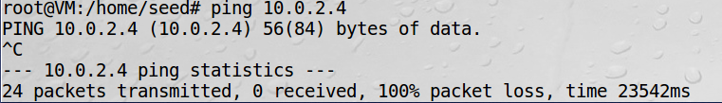

As observed and expected the firewall implemented in Machine A would prevent any ping request from Machine B through ICMP. It can be noted that there was a 100% packet loss, which would explain the DROP command in the firewall to drop all incoming ICMP protocol packets, which successfully achieved the aim of this task. Furthermore it was important to understand the effect of dropping Machine A’s Iptable rules, whether a ping request can again be successful. This was done by clearing all Iptable rules in Machine A, and sending the ping request from Machine B (Figure 23 & 24).

*Figure 23: Dropping all Iptable rules*

*Figure 24: Ping requests resuming in shell*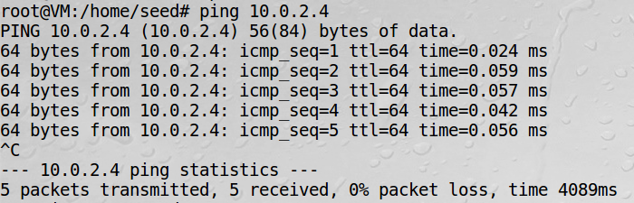

As observed after removing the Iptable firewall constraint the ping requests can again be restored. Thus the key takeaway would be the ability to control which protocol requests to accept or deny when creating a firewall.

**5.2 Nmap**

**Task 1 Normal Scan**

This task incorporated making use of the Network Mapper tool ‘nmap’, which was an open source tool available for use in a Linux environment with network scanning and vulnerability discovery [4]. The first task required the use of this tool and a virtual machine that was connected to the internet. Firstly the virtual machine was setup-up with an IP address of 10.0.2.15 (Figure 25).

*Figure 25: Machine A network information* 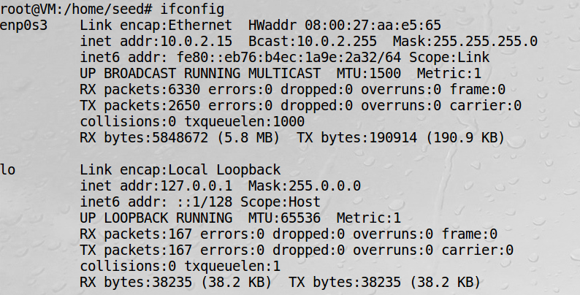

After setting up the virtual machine the next step was to install the ‘nmap’ tool on the operating system to make use of the network scanning capabilities. This was done using the following command (Figure 26).

*Figure 26: Shell command to install nmap* 

After installing the ‘nmap’ tool on the virtual machine, the premise of this task incorporated exploring the normal nmap scanning flag. Before any flags from the nmap tool could be utilized, the shell environment needed to be set up in root mode, to modify the privileges to run the nmap tool (Figure 27). 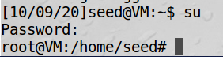

*Figure 27: Root Mode shell request*

The final step was to actually conduct the network scan, which was done to probe this Machine’s IP address (10.0.2.15) as the target port to conduct a network scan. The following command below was used to conduct this request (Figure 28).

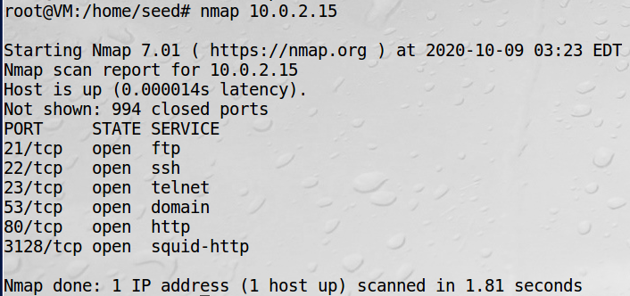

*Figure 28: Normal nmap scan shell command*

After executing this command it observed the results of the nmap scan (Figure 29). From this it is understood what each field and the output results mean, ‘man nmap’ was used to understand the output. It was noted that various information about the current Machines operating system network was displayed. This included the IP address for which the nmap scan was occurring. The ‘994 closed ports’ existed, since the nmap tool would only show the ports that were open using the virtual machine’s IP address. From this, it was evident that for the virtual machine port 21, 22, 23, 53, 80 and 3128 were in the OPEN state. More information that could be observed was the services that were using the machines port. These services included ftp, ssh, telnet, domain, http and squid-http [5].

*Figure 29: Normal nmap scan output*

After conducting this task, using the normal flag for ‘nmap’, the key learning and takeaway was the ability to understand what services any device on the network is running, as well as what poor that service is binded to on that machine. This information could be useful for exploiting a target machine's vulnerabilities.

**Task 2 UDP Scan**

The second task utilizing the ‘nmap’ scanning tool, involved adding flags to conduct a UDP scan. It was known that the nmap UDP scan is a connectionless protocol, such that the three-way TCP handshake doesn’t exist. The UDP involves a client and server that communicate, such that the connection involves ICMP protocol, as the response from a machine the port status of the machine can be determined to be in the OPEN/CLOSED state. If there is an ICMP response from the machine then this would tell the attacker that some ports are CLOSED, if there is no response from the target then the attacker can deduce that some ports are OPEN. To trigger this response UDP packets are sent to every port on the victim's Machine[6].

The first step in conducting the nmap UDP scan was to again enter the root mode on the Machine, this allowed the scan to bypass and alter existing privileges (Figure 30). This root access within the shell was done on the target machine itself with the IP address of 10.0.2.15.

*Figure 30: Root mode access*

After root access was attained the next step was to execute the nmap UDP scan within the shell environment. The ‘-sU’ flag was used, which specified the scan type as a UDP scan. The ‘-sS’ flag could have also been used to combine the scan with a TCP scan. However due to the aim of this task to only conduct a UDP scan, this option was mitigated [7]. The next specifier was the IP address of the target Machine, which was the local machines IP address of 10.0.2.15. It was predicted that the UDP packets would be sent to every port of the selected target machine, and for the open ports an ICMP protocol packet would be observed in the Wireshark feed. The result of executing this command was observed below (Figure 31).

*Figure 31: UDP nmap scan output*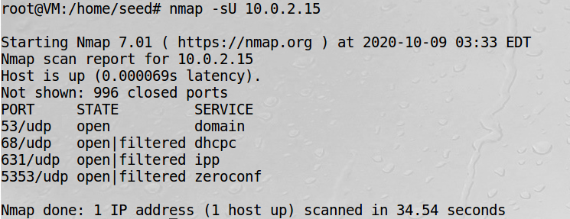

By executing the nmap UDP scan, it was observed that in the shell returned various information about the ports on the target machine. This scan deduced that 996 ports were in the CLOSED state and 4 were OPEN, which included ports 53, 68, 631 and 5353. Information deduced from this UDP scan also included the services that these ports were being used for, which included domain, dhcpc, ipp and zeroconf. Furthermore, whether or not the ports had some type of firewall existing, this was represented by the state being OPEN/FILTERED. Ports that had some type of firewall included ports 68, 631 and 5353.

To understand more of the packets sent and received during the UDP scan, it was important to also run Wireshark concurrently with executing this command. After running this command it was observed that there were UDP requests from the from nmap scan, which were looking for information about the port status and the services running. It was also observed that there were some ICMP response packets. These ICMP response packets displayed the message ‘[Port Number] Port Unreachable’. This type of response packet explains in the UDP nmap scan the ports that are in the CLOSED state (Figure 32).

*Figure 32: Wireshark packet capture*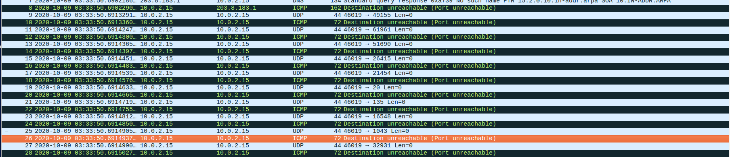

By furthermore exploring the ICMP packet, the ICMP response metadata was viewed and interpreted. From this field as ‘3’ for Type and Code states that a specific port or destination is unreachable. The UDP can also be viewed in the ICMP packet, with information about the UDP request (Figure 33).

*Figure 33: ICMP packet payload* 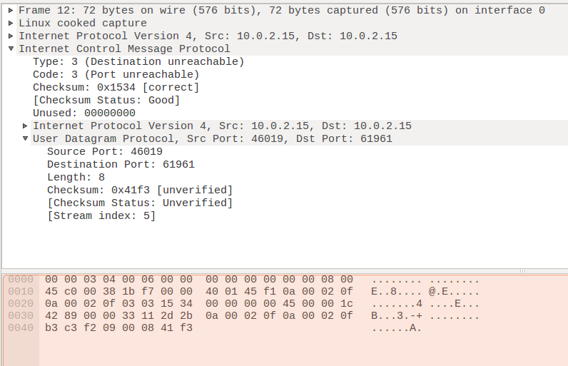

Thus, by completing this nmap UDP scan, information about whether the target Machines ports being open or closed could be determined. It was also understood that this was done by sending UDP request packets, and capturing ICMP response packets for an attacker to infer information about what ports for a target are OPEN or CLOSED. The key takeaway was that nmap used a rejected ICMP message to determine port state.

**Task 3 Xmas Scan**

The final nmap task incorporated making use of the ‘XMAS SCAN’. Also known as the ‘Christmas Scan’. The xmas nmap scan involves the sender analysing a target machine's response to the xmas packets sent during the scan, to learn information about the operating system. For the xmas scan to be successful, it requires three types of flags. The first includes PSH or PUSH, which incorporates informing the destination that data is requested to be sent immediately. The next flag is the URG flag, which prioritises specific urgent data segments. The final flag part of the xmas scan is the FIN, which sends connection termination requests from the interacting host, and stalls until the request is received. The combination of these three flags is illegal, hence the xmas packet should always be rejected and dropped by the target machine. The significance of this is that by being rejected by the target machine, this scan allows the sender to understand what ports rejected this xmas packet, hence can be understood as OPEN ports [8].

To conduct this final task the target and scanner machine was placed in root mode, to enable the xmas privileges to be accessed. The machine was again on the IP address of 10.0.2.15, this was to be the target as well as the scanning device (Figure 34).



*Figure 34: Root mode access*

After placing the shell environment in root mode access, the next step was to execute the xmas nmap command. This was done again by using the ‘nmap’ specific to access all tools and resources dependencies for nmap scanning. The flag ‘-sX’ represented the xmas scan, which would contain all three types of the FIN, PSH and URG flags. Finally the target IP address of 10.0.2.15 was also placed in the command, as the target for the nmap scan to be conducted. Before executing this, the Wireshark capture was opened. It was predicted that because TCP segments are used for PSH and URG, the ports which rejected the three flags, would have their services listed that are running on those ports using the TCP connection (Figure 35).

*Figure 35: XMAS nmap scan in shell*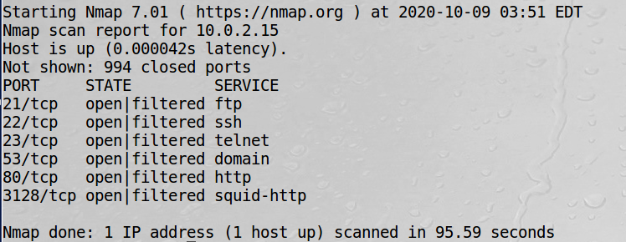

*Figure 36: XMAS nmap scan results*

From the result above (Figure 36), it is evident that the ports that rejected the three flags were ports 21, 22, 23, 53, 80 and 3128. These ports were expected to be in the OPEN state as that was described as the conditions to reject the xmas packets. However it was observed that they were in the OPEN/FILTERED state, which would suggest a firewall protection measure was in place for the listed ports. The other information as to the type of service these ports had a TCP connection, which included ftp, ssh, telnet, domain, http and squid-http.

To understand fully how the packets were sent, received and dropped it was important to interpret the Wireshark captured packets (Figure 37). From this it can be seen the port number which the xmas nmap is being sent to, as well as the three flags of FIN, PSH and URG. This demonstrated that the xmas packets had successfully reached the target machine.

*Figure 37: Wireshark TCP packet capture*

By looking deeper into these sent packets in Wireshark, more information can be understood about the TCP connection, since the three main flags existed in the TCP header (Figure 38). It was observed that with port 23, the URG, PSH and FIN flags were all in the position ‘SET’, whilst all the other flags were ‘NOT SET’. This was representative of the ‘Christmas Tree’, as light blinking on and off. With these three flags set, this represents why the information displayed about port 23 was displayed. Since the xmas scan would return information only about open ports which reject and drop the TCP request.

*Figure 38: TCP packet payload* 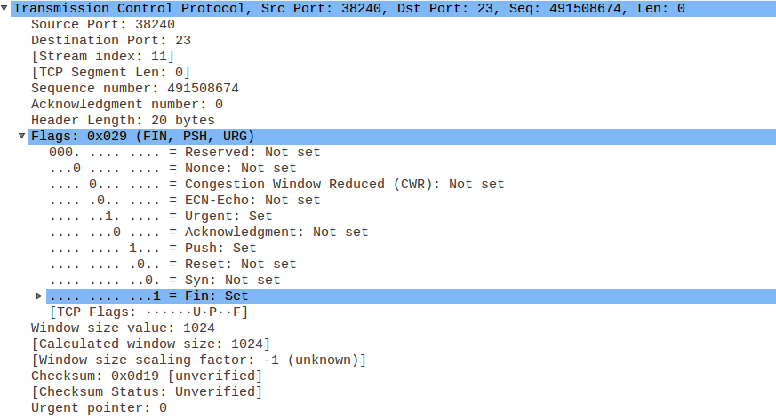

Thus the key takeaway was how the nmap xmas scan operates, by sending an illegal combination of flags to open ports, waiting to be rejected and understanding information about those ports. Furthermore, it was learnt that the xmas scan is a stealthy method in scanning, since it analyses a machine's response to xmas packets to infer information about that machine.

**5.3 Snort**

**Task 1 Normal NMAP Flag Alert**

Within the Ubuntu environment exists the network intrusion detection tool Snort, which works by performing real time packet analysis for IP addressee that are either incoming, outgoing or both on a network or local machine [9]. This tool allows users to use existing or create unique personalised rules for detecting a variety of traffic packets movement on a network. This first task task involved utilizing this tool to detect when a Normal nmap scan is in progress. Firstly the snort tool needed to be installed on the local Machine (10.0.2.15). This installation was done using the command below (Figure 39).



*Figure 39: Shell snort installation*

After installation the next step was to familiarize with the main file which contained all the rules for snort. Since this task specifies that the local machine needs to be notified, the snort.conf file was modified, by changing the target IP address for protection to the IP address of the local machine (10.0.2.15) (Figure 40).

*Figure 40: Snort config file update*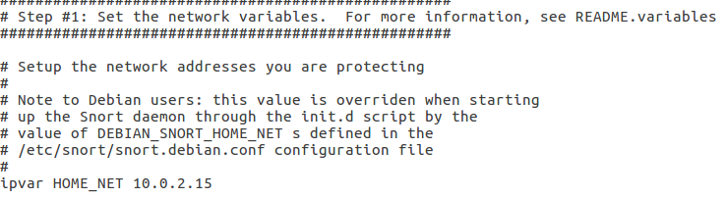

After setting up the snort.conf file it was observed that this file executes a file called local.rules. This local.rules file would be the file for all the snort detection policies code that exists to notify Machine A of any specific type of attack on the device. Accessing both the snort.conf and local.rules files was done using the following commands (Figure 41 & 42).



*Figure 41: Command to edit config file*

*Figure 42: Command to edit local rules file* 

Once opening these files, the next step to detect the normal nmap scan was to add an alert rule in the local.rules file (Figure 43). This statement contained various flags and parameters that will notify Machine A when an nmap scan is in progress. The ‘alert’ mode parameter will display in the snort console when a snort rule condition is met in the local.rules file. By selecting ‘any any -> 10.0.2.15 any’, this requests snort to scan all ports on the local machine (10.0.2.15), for any ‘tcp’ packets coming from any IP address and any port. The reason ‘tcp’ packets to be scanned was that the normal nmap command sends the TCP ACK packets to all the ports of a specific target IP address [10]. Hence, by detecting when this type of packet is sent to the local machine ports, it can be deduced that an nmap scan is potentially in progress. The next field ‘msg’, was the text message to display in the snort console when the conditions previous and after are met, which in this task would be the normal nmap scan. The ‘sid’ field was used to uniquely identify this snort rule, since multiple snort rules could exist in the local.rules file. Finally the ‘rev’ field was set to 1, using this field allowed for unique revisions for this snort rule, this is combined with the ‘sid’ field as well to enable any disngitures/descriptions to be modified and replaced with any information that is updated [11]. Thus, after creating and saving this rule in the child file of snort.conf, the next step was to wait for the nmap scan and detect the conducted nmap scan [12].

*Figure 43: Snort local rule for normal nmap alert*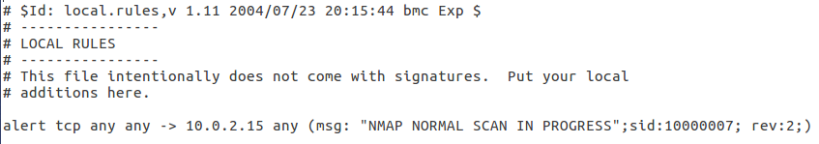

This was done firstly on Machine A running snort, the following command was used to turn on snort NIDS (Network Intrusion & Detection System). With this mode, the link from snort.conf to local.rules will run, and capture all traffic packets, the created rule for the normal nmap scan should be detected and the warning message displayed within the NIDS console mode. The command was executed with a number of flags and conditions including the ‘-A’ flag, which runs all alerts created from the linked local.rules file. The ‘-q’ ensures the console is in quiet mode, such that it hides the status and banner reports. The ‘-c’ flag points snort to the snort.conf file, which enables the linked local.rules file to run. Finally the ‘-i’ allowed for enp0s3 condition to be specified as this was the network interface name. This had to be first deduced using the ‘ifconfig’ command, and input into the snort initial configuration settings (Figure 44).

*Figure 44: Network interface name*

Once, correct network interface was set up, the next step was to execute the NIDS mode, and conduct the normal nmap scan. This attack was done from another terminal with IP 10.0.2.15, using the normal nmap scanning flag (Figure 45)

*Figure 45: Normal nmap scan*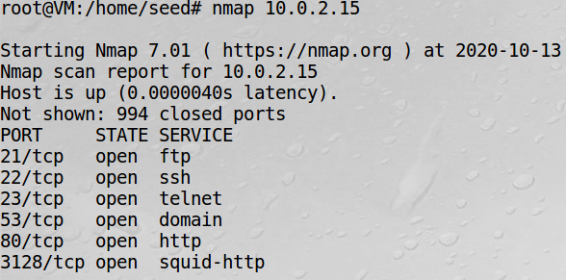

As previously conducted the TCP ACK packets are sent to all the ports of the target machine 10.0.2.15. After this, the OPEN ports were again deduced and viable by the machine conducting the normal nmap scan. However, switching back to the NIDS console, it was observed there were multiple statements which coincided with the created alert (Figure 46). This alert showed all information about the nmap scan in progress, including the source and destination IP, time and date stamp, TCP packet capture, the ‘sid’ and ‘rev’ identifiers, and a priority 0 was given. This automatic assignment by snort, suggested that the classification of the priority was 0, which is not on the list of 1 (high) to 4 (low) in severity.

*Figure 46: Alert in shell console about nmap scan*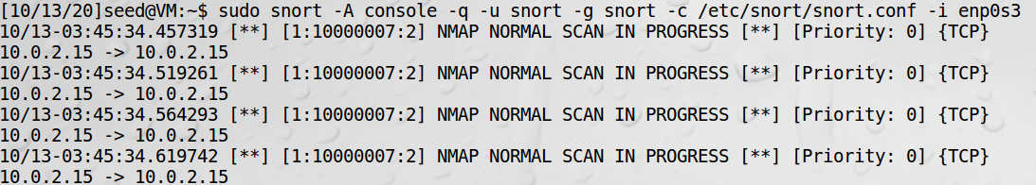

During the nmap normal scan, the TCP packets were also again captured in Wireshark (Figure 47). From this it was noted the TCP SYN ACK packets reaching all the ports of the target Machine A. It would be at this point the alert in the local.rules would display in the console that TCP packets from an nmap scan are reaching all the ports.

*Figure 47: Normal nmap scan Wireshark capture* 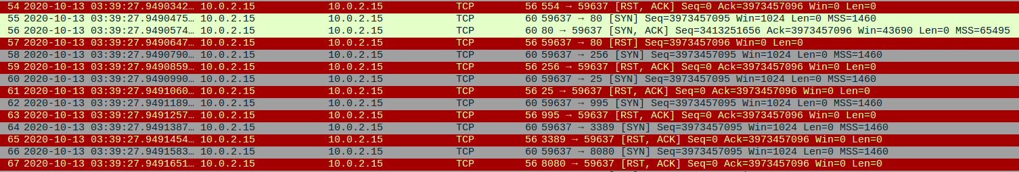

Thus, after concluding this task, the main takeaway was the flexibility in creating an alert to notify the snort machine when an attack could be taking place. This is important as larger systems when a potential threat is detected, countermeasures can then be executed to prevent any further compromisations of CIA.

**Task 2 NMAP Flag UDP Alert**

The second task which made use of snort incorporated an alert to the target Machine A (10.0.2.15), when an nmap UDP scan was in progress. It was firstly known that the nmap UDP scan functions by UDP packets being sent to every port of the target machine, and the attacker waiting for the ICMP packets to determine whether the ports are opened or closed [7]. To be aware of this type of scanning intrusion attack, the local machine can have a snort rule, which is defined to detect this type of scanning flag.

This was done by firstly again opening the local.rules file which is linked to the main snort.conf file. Using the snort manual it was deduced that multiple alerts can be created, with the detection of ICMP and UDP packets part of the included functions in the snort.conf. Since the nmap attack and detection would be done by the same IP address machine as 10.0.2.15, it was important to capture both UDP and ICMP packets, which are part of the UDP scan for sending and receiving a response. This was done by specifying two rules with various flags and conditions. The two types of flags were set to ‘udp’ and ‘icmp’, which the types of packets captured to be alerted on. For UDP, the from and destination fields were ‘any any -> 10.0.2.15 any’, which specified any UDP packets attacking any port on the local machine. Then for the ICMP packets, the from and destination fields were 10.0.2.15 any -> any any’, which specified any ICMP packets that were leaving the local machine and giving information to an attacker machine about the state of ports on the local machine. Both alerts had distinct messages, which were to be displayed in the console when a UDP nmap scan is in progress. The two alerts also had a ‘sid’ and ‘rev’ specified to uniquely identify these types of rules from the snort.conf file. The ‘dsize’ flag was also turned on to ensure that any packets didn’t cause a buffer overflow, which could compromise the integrity of the local machine (Figure 48).

*Figure 48: Snort UDP nmap local rules*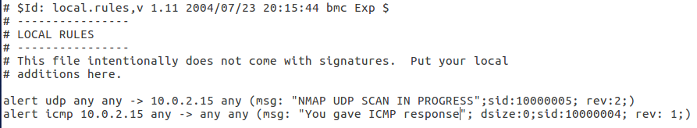

After creating this rule, it was saved and the next step was to evaluate whether or not the alert was successful. This was done on the attackers terminal shell using the nmap udp scan flag to the local machine's IP address 10.0.2.15. Again the attacker can deduce the ports that are open by analysing the ICMP response after sending UDP packets to every port (Figure 49).

*Figure 49: UDP nmap scan*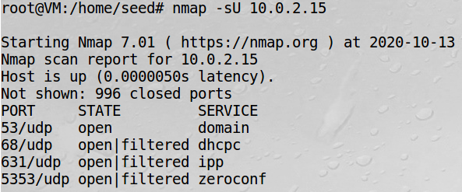

After executing this command on the attackers shell, simultaneously the NIDS mode was set up on the snort detecting shell. This was again done with the same enp0s3 network interface type. From this it was observed the alerts created in the local.rules file, appeared in the console. These alerts showed both incoming UDP packets and outgoing ICMP packets. Again the time stamp, sid and rev identifier, warning message, priority, packet type and source and destination IP addresses were displayed. From this, it can be noted that an ICMP response was sent in the middle of multiple received UDP packets, which lets the snort machine know that the attacker knows which ports are in the OPEN/CLOSED state. The priority for the UDP packets were listed as 0, meaning it wouldn’t compromise the system. Whilst snort categorised the ICMP response as 3, which is moderately low severity (Figure 50).

*Figure 50: UDP nmap snort alert detection* 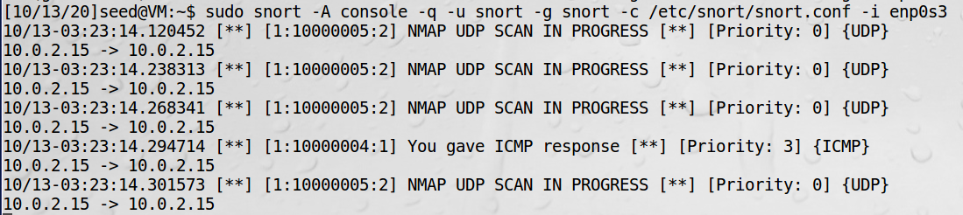

Again looking at the Wireshark capture, all the UDP and ICMP packets can be observed, with an ICMP response sent each time a port is in the CLOSED state (Figure 51).

*Figure 51: UDP nmap Wireshark capture*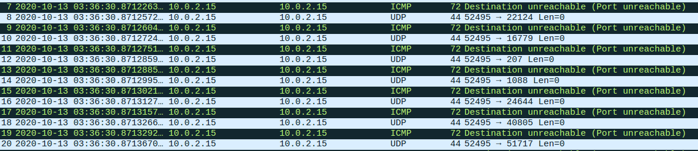

Thus, the key learning from this was the ability of snort to capture multiple types of packets and alert the snort running machine. It was important to have run the attack and snort on the same machine, as the receiving of the ICMP packets in the UDP nmap scan could also be detected.

**Task 3 NMAP Flag XMAS Alert**

The third type of network intrusion detection snort alert task, involved notifying the console when a potential nmap XMAS scan is in progress. It was known that the nmap xmas scan works by sending TCP packet segments to the target machine, with specific flags having specific conditions set. This included the combination of FIN, PSH and URG being illogically interpreted by the receiving machine and then dropped. This then gives information to the attacker about the TCP services running and the OPEN/CLOSED status of the victim's ports [8].

To complete this attack the victim's machine was set on the IP address of 10.0.2.15, and xmas scan would be done on the same machine in a separate shell with IP address 10.0.2.15. The first step was to add a rule in the snort.conf linked rules file, local.rules. Since TCP segments were sent, the selected packet type to scan for in snort was set to ‘tcp’. Again the source and destination was set as ‘any any -> 10.0.2.15 any’, which would alert for any TCP packets within the condition that are sent to any of the ports on the local machine. A message was set, which would again display in the console each time a potential nmap XMAS attack could be in progress. The condition ‘flag’ was also used, this allowed for bits in the TCP segment to be set. In the XMAS scan, the FIN, PSH and URG flags as ‘FPU’ were selected as bits being set, since they ‘light up the christmas tree’. Doing so enabled a distinction between a normal TCP packet, and this XMAS TCP segment. Finally the ‘sid’ and ‘rev’ fields were also set, so that the snort.conf can uniquely identify this created snort rule. The file was saved, and snort ran to check and show if any errors existed in creating this alert (Figure 52).

*Figure 52: XMAS nmap snort rule*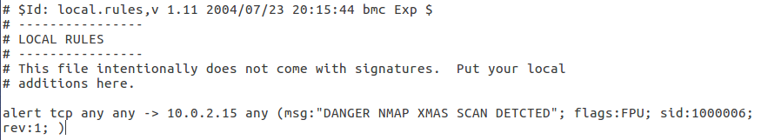

After creating this rule the next step was to conduct the XMAS nmap scan, and check if the snort rule alerted the local machine about the potential attack. This was done by starting the nmap XMAS scan on the attackers shell of IP address 10.0.2.15 (Figure 53).

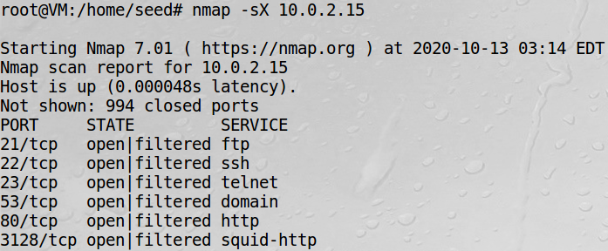

*Figure 53: XMAS nmap scan*

During the XMAS nmap scan, the snort NIDS console for the enps03 network interface was executed in the victim's shell. From this it was observed the TCP segments were reaching the port of the local machine. With the alert message displayed in the console. Again the time stamp, sid and rev identifier, warning message, priority, packet type and source and destination IP addresses were displayed. It was assumed that the TCP segments which met the conditions of the FIN, PSH and URG flag bits were set on. Priority was again set as 3, which is a moderately low severity impact on the local machine (Figure 54).

*Figure 54: XMAS nmap sort alert detection*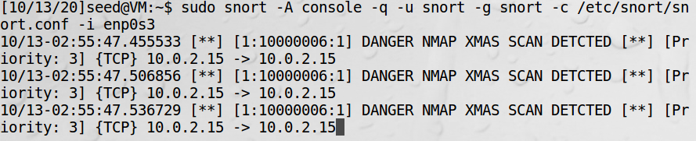

During this attack, again looking into the Wireshark capture, the TCP segments were observed as previously done when completing the nmap XMAS attack. It can be seen the three types of flags being set, before reaching each port of the local machine to be a dropped packet (Figure 55).

*Figure 55: XMAS nmap Wireshark capture*

Thus the key learning was the ability to specify the bits that are sent in the packet segment, when doing to snort. This ensured that normal TCP packets say for browsing weren't captured, only TCP packets that meet the flags for an XMAS nmap scan. Using snort to detect these packets is significant, as the nmap scan is also known as the ‘stealthy’ scan going undetected.

**Task 4 Website Alert**

The fourth task involved making use of the snort to detect when the local machine was accessing a specific website. This specific website in question had the domain ‘staff.uq.edu.au’. To complete this task, again the snort.conf linked local.rules files was modified with an alert to be added, which should notify on the event when the local machine (10.0.2.15) accessed the specified domain. It was known that TCP packets are used in the transfer of information between the web server/web application and the local machine. Hence the first step was to capture the IP address of the destination entity, which was the webserver. This was done in root mode using the ping command (Figure 56).

*Figure 56: Web Server ping result* 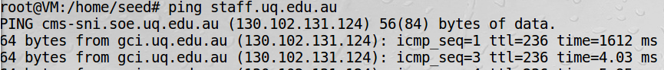

When creating the snort rule and conducting this task, specifying the IP address in the rule as destination should trigger the alert, hence, this IP address was specified in the created rule. The source and destination was set as 10.0.2.15 any -> any any’, which would be activated when the local machine tried to access any destination which met the list of conditions. This was important, as TCP requests from the destination to the source are encrypted and cannot be filtered. Thus, the TCP packets from the encrypted local machine to the server would be captured. Since it was known the transfer of information from the web server would be via TCP packets, the packet type to capture was set as ‘tcp’. The next step was since the IP address wasn't previously working, and was to list the domain. This was done using the ‘content’ flag, which checks the TCP packet load for the IP address ‘130.102.131.124 ’. Setting this would allow for only access to this website to be noticed by the local machine. The location of this existed within the TCP segment, as evident when capturing the TCP packets when visiting the website from Wireshark (Figure 57)

*Figure 57: TCP packet payload content* 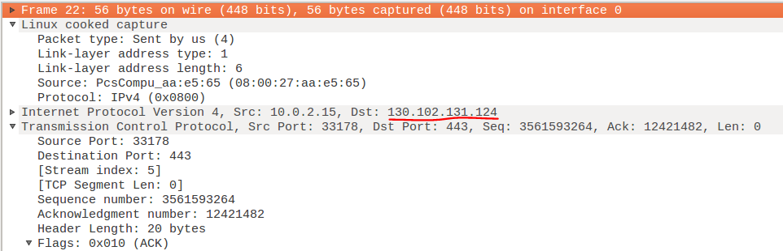

After deducing that snort could evaluate the TCP segment for this IP address source, the remaining flags of the rule needed to be specified. This included the message to display within the console. As well as using ‘sid’ and ‘rev’ to ensure that snort.conf determined the created rules were uniquely identified (Figure 58).  
 *Figure 58: Web server snort detection alert*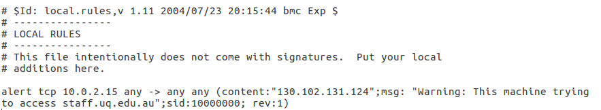

After saving the rule on the rules folder, the next step was to access the listed website and wait for an alert to be present in the snort console. This was done by accessing the domain ‘staff.uq.edu.au’ on the firefox browser (Figure 59).

*Figure 59: Target alert web server* 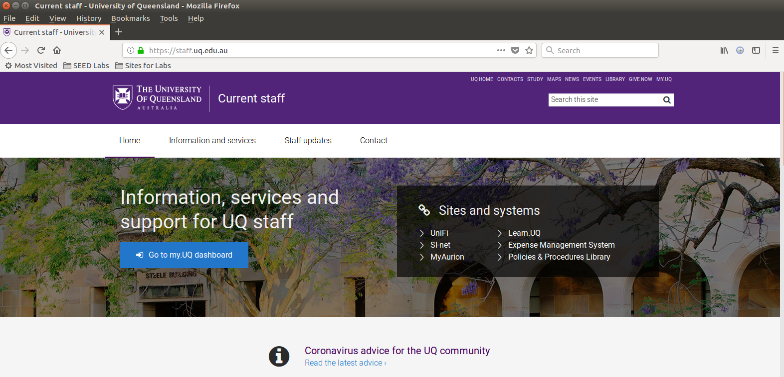

Before accessing this domain, the snort console was again open and ran with the network interface enp0s3 (Figure 60). From this it was observed that multiple TCP segments contained the content of the domain IP address. With the required message ‘Warning: This machine is trying to access staff.uq.edu.au’ alerts displayed for each TCP packet sent. Again the time stamp, sid and rev identifier, warning message, priority, packet type and source and destination IP addresses were displayed. The priority set as 0 can be interpreted as not on the 1 (high) - 4 (low) severity scale, as the machine is just trying to connect to a web server for a specific domain.

*Figure 60: Web server snort alert detection* 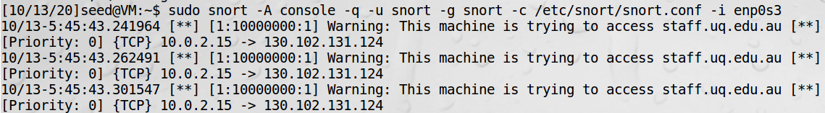

Thus the key takeaway from this task was the usefulness of the content specifier, such that snort can interpret unencrypted TCP packets for keywords specified in the continent. The ramifications of this could be important in an intelligence agency or workplace browsing censorship and tracking of activity.

**Task 5 SSH Brute Force Special Condition Alert**

The last task incorporated utilizing snorts NIDS rules, to alert the host machine of a potential SSH Brute Force Attack. Firstlly, the SSH Brute Force attack would incorporate multiple login authentication attempts, to attain access to an SSH server [14]. It was also known that SSH uses TCP packets to send and receive information between two entities [15]. The conditions to which this attack was to occur, was that the attacker must have at least 5 failed SSH login attempts within a 120 second time period. If this condition is met, then the local machine should be alerted that a potential SSH Brute Force Attack may be taking place.

The first step involved creating and setting up a remote SSH server on the target machine (10.0.2.15), for the attacker machine (10.0.2.4) to attempt to login via SSH. After installing the SSH service via the command ‘sudo apt-get install openssh-server’, the config file needed to be modified to enable various conditions (Figure 61).

*Figure 61: Command to edit config file*

This included allowing for the root SSH server to be created on the local machine, which was the only way to create the SSH server (Figure 62).

*Figure 62: Edit config authentication* 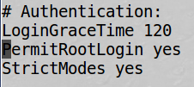

The other modification was to allow password authentication, which would allow for other machines to connect to the server, by verifying a password entry was satisfied (Figure 63)



*Figure 63: Edit config password allowance*

After setting up the SSH config file, the next step was to create an SSH server on the local machine. This was done using the newly enabled root as the username to create the server (Figure 64)

*Figure 64: Set up SSH server* 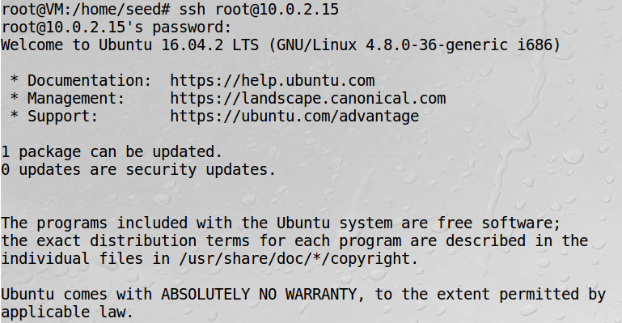

The next step was to develop the rule within the snort.conf file to alert the local machine when the potential Brute Force SSH attack was taking place. This was done firstly using TCP as the packet type, since SSH uses TCP to send and receive packets with the SSH server. The source and destination was set as ‘any any -> $HOME_NET any’, which would alert for any TCP packets that reach the SSH server, that if the condition is satisfied an alert needs to be displayed in the console. The message was set as ‘SSH Brute Force Attack In Progress’, which was easily understood in the console. Next was the ‘flag’ condition, which was set as ‘S+’. This was done to check for the ‘SYN-ACK’ in the three way handshake event that is going on in the login. This is such that the SSH server poses a challenge-response protocol for a password, a potential flaw could be a SYN flood attack. Hence detecting this flag is an *extra* countermeasure against a SYN Flood attack. The next flag used was the ‘threshold’, this argument allowed multiple specifications regarding the login action by the user. The first argument was ‘type both’, requiring both end conditions to be true before the alert is sent, this was as the spec sheet required at least 5 failed login and the time to be 120 seconds. The ‘track_by_src’ argument ensured that the rules were isolated per IP address, and applied to each individual IP address not username. The next two arguments of ‘count’ and ‘seconds’, would be for 5 failed logins during a full 120 seconds for a specific IP address the alert would be triggered. Finally the ‘sid’ and ‘rev’ was set to ensure each unique set for the alerts in the snort.conf file (Figure 65).

*Figure 65: SSH Brute Force snort rule* 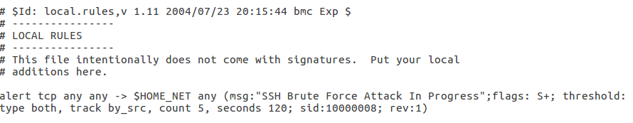

After saving this last rule in the snort.conf file, the next step was to attempt to fail login on another machine. This was done on Machine B (10.0.2.4), which attempted to connect to the SSH server on the local machine (10.0.2.15). When connected, to evaluate the rule minimum of 5 failed login attempts within the 120 second time period was required. Testing the boundaries, a set of 10 failed login attempts were done within a time period of 240 seconds, to check if the rule reset after the time expired (Figure 66).

*Figure 66: Machine B attempted SSH Brute Force attack*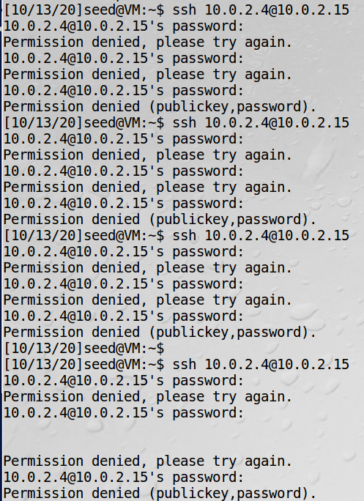

At the same time as creating these SSH server authentication failed login requests, the snort console was opened on the local machine with the enps03 network interface (Figure 67). As observed in the console two alerts consistent with the newly created snort.conf rule was active. Information displayed was the time stamp, sid and rev identifier, warning message, priority, packet type and source and destination IP addresses were displayed. The priority set as 1 can be interpreted as 1 (high) on the severity scale, as the attacker machine might be trying to conduct an SSH Brute Force attack. The message alert of ‘SSH Brute Force Attack In Progress’ was displayed to notify the local machine where the server is created on. The source and destination of the origin of the potential attack 10.0.2.4 is also visible to the local machine, to potentially block or apply any countermeasures to prevent such attack.

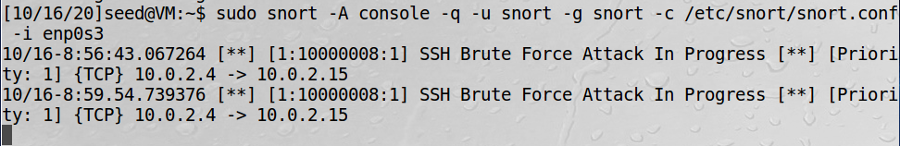

*Figure 67: Snort SSH Brute Force attack alert*

Thus, after completing this task the key takeaway from this was the flexibility in conditions with a snort rule, such that a time, count and specific IP address external from the local machine could be tracked with access to a server. This is important to quickly be alerted by this information, to block the IP address and prevent a Brute Force Attack.

**6.0 References**

[1]S. Gridelli, "How to use telnet to test connectivity to TCP ports", *NetBeez*, 2020. [Online]. Available: https://netbeez.net/blog/telnet-to-test-connectivity-to-tcp/. [Accessed: 20- Oct- 2020].

[2]"How to find the IP address of a website or server", *Nexcess*, 2020. [Online]. Available: https://help.nexcess.net/77289-ip-management/how-to-find-the-ip-address-of-a-website-or-server. [Accessed: 20- Oct- 2020].

[3]"What are ICMP PING responses?", *Docs.netapp.com*, 2020. [Online]. Available: https://docs.netapp.com/ess-11/topic/com.netapp.doc.ssm-sam-116/GUID-649BE1AD-24F5-4B3D-892D-8AF14C37619C.html#:~:text=Internet%20Control%20Message%20Protocol%20. [Accessed: 20- Oct- 2020].

[4]M. Ferranti, "What is Nmap? Why you need this network mapper", *Network World*, 2020. [Online]. Available: https://www.networkworld.com/article/3296740/what-is-nmap-why-you-need-this-network-mapper.html. [Accessed: 20- Oct- 2020].

[5]V. Gite, "nmap Command: Scan A Single IP Address or Host - nixCraft", *nixCraft*, 2020. [Online]. Available: https://www.cyberciti.biz/faq/howto-scan-single-ipaddress-host-using-nmap/. [Accessed: 20- Oct- 2020].

[6]"[Lesson 6]Network Vulnerability and Scanning: UDP Scan in Nmap", *Medium*, 2020. [Online]. Available: https://medium.com/@koayyongcett/lesson-6-network-vulnerability-and-scanning-udp-scan-d06c75787f5. [Accessed: 20- Oct- 2020].

[7]"UDP Scan (-sU) | Nmap Network Scanning", *Nmap.org*, 2020. [Online]. Available: https://nmap.org/book/scan-methods-udp-scan.html. [Accessed: 20- Oct- 2020].

[8]"Nmap Xmas Scan – Linux Hint", *Linuxhint.com*, 2020. [Online]. Available: https://linuxhint.com/nmap_xmas_scan/#:~:text=Nmap%20Xmas%20scan%20was%20considered. [Accessed: 20- Oct- 2020].

[9]"What is Snort?", *Snort.org*, 2020. [Online]. Available: https://www.snort.org/faq/what-is-snort. [Accessed: 20- Oct- 2020].

[10]"A Quick Port Scanning Tutorial | Nmap Network Scanning", *Nmap.org*, 2020. [Online]. Available: https://nmap.org/book/port-scanning-tutorial.html. [Accessed: 20- Oct- 2020].

[11]"3.4 General Rule Options", *Manual-snort-org.s3-website-us-east-1.amazonaws.com*, 2020. [Online]. Available: http://manual-snort-org.s3-website-us-east-1.amazonaws.com/node31.html#keyword_sid. [Accessed: 20- Oct- 2020].

[12]R. Chandel, "How to Detect NMAP Scan Using Snort", *Hacking Articles*, 2020. [Online]. Available: https://www.hackingarticles.in/detect-nmap-scan-using-snort/. [Accessed: 20- Oct- 2020].

[13]"What Does it Take to Get a Web Page?", *Cs.bu.edu*, 2020. [Online]. Available: http://www.cs.bu.edu/~best/courses/cs109/modules/getwebpage/. [Accessed: 20- Oct- 2020].

[14]"What Is SSH and How Do Hackers Attack It - Cyclonis", *Cyclonis*, 2020. [Online]. Available: https://www.cyclonis.com/what-is-ssh-how-hackers-attack/. [Accessed: 20- Oct- 2020].

[15]"SSH uses four TCP segments for each character you type - Nikhil Mungel", *Blog.hyfather.com*, 2020. [Online]. Available: http://blog.hyfather.com/blog/2013/04/18/ssh-uses-four-tcp-segments-for-each-character/. [Accessed: 20- Oct- 2020].